SECOND QR CODE NEAR ROAD

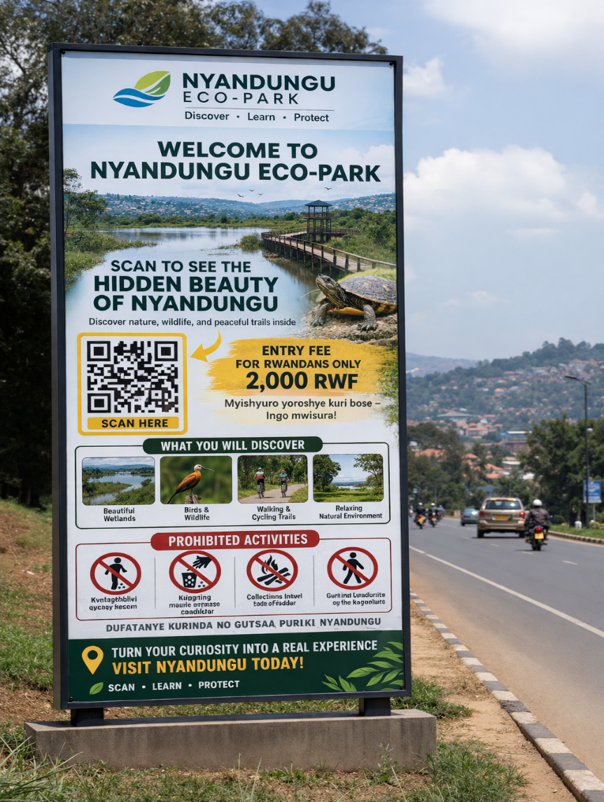

Welcome to Nyandungu Eco-Park / Murakaza neza muri Nyandungu Eco-Park

Ibyiza Wasura muri Nyandungu Eco-Park / Top Highlights to Explore

- Amafunguro n’Ibinyobwa (Dining & Refreshments)

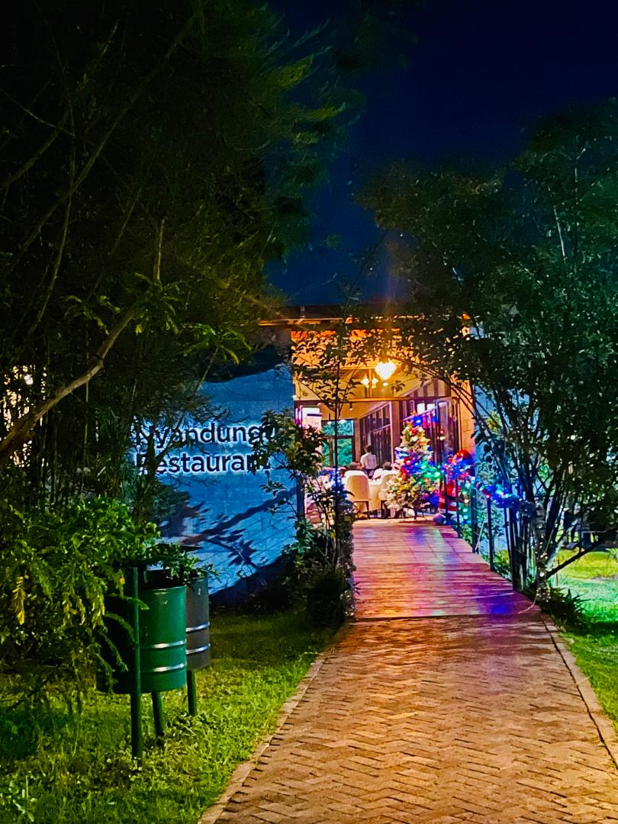

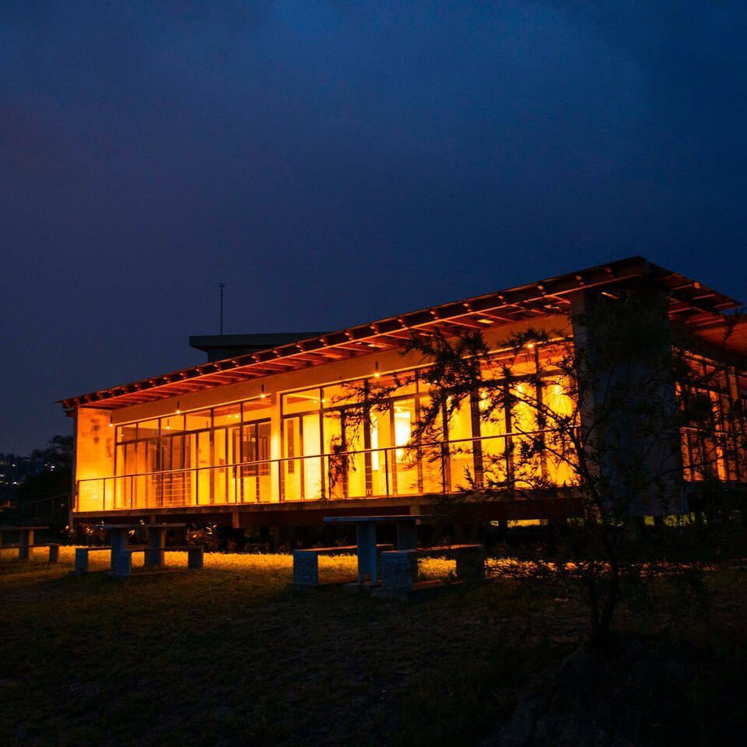
- IBIYAGA BIHANGANO/ PONDS

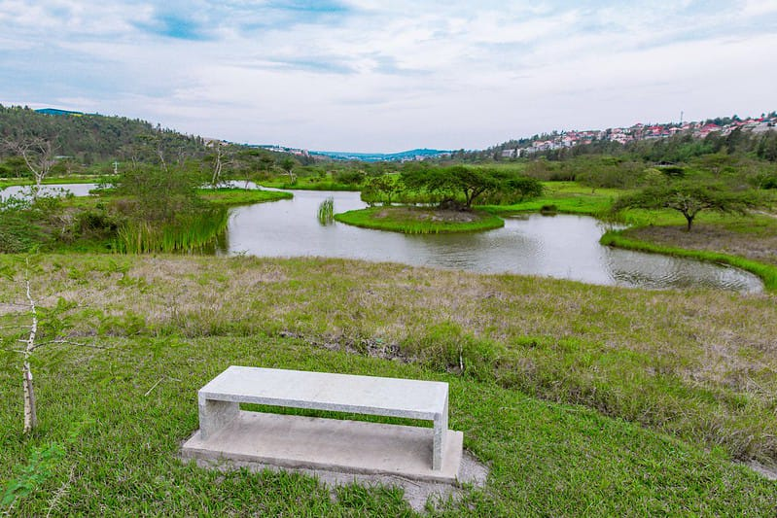

- INYONI NZIZA CYANE / BIRDS

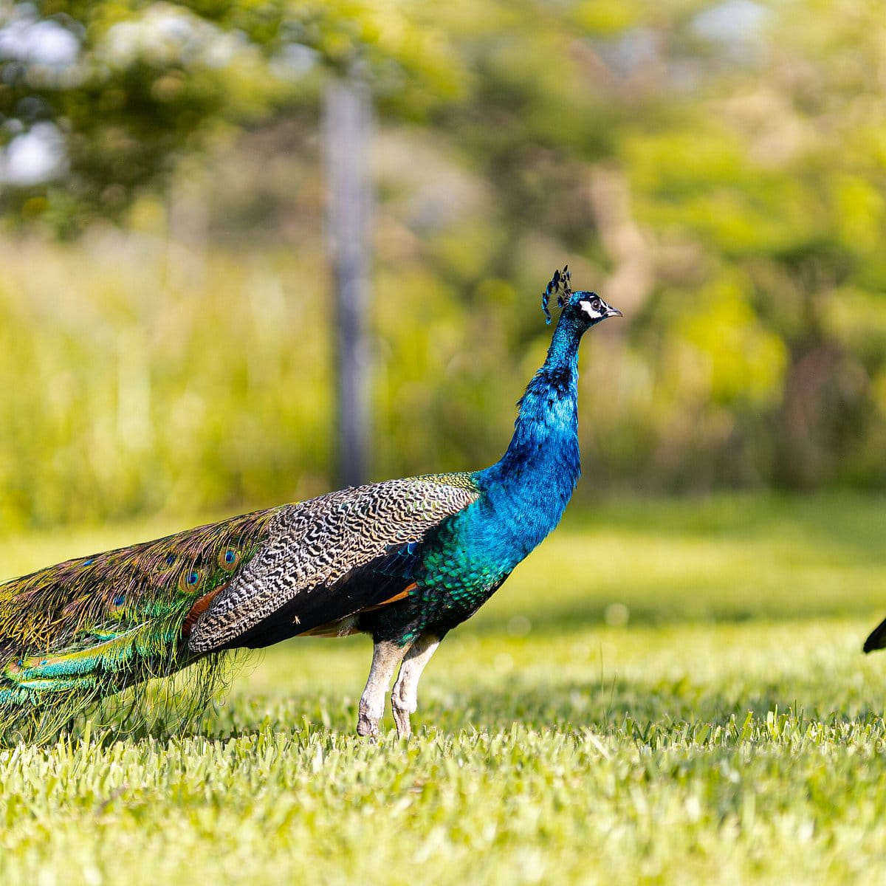

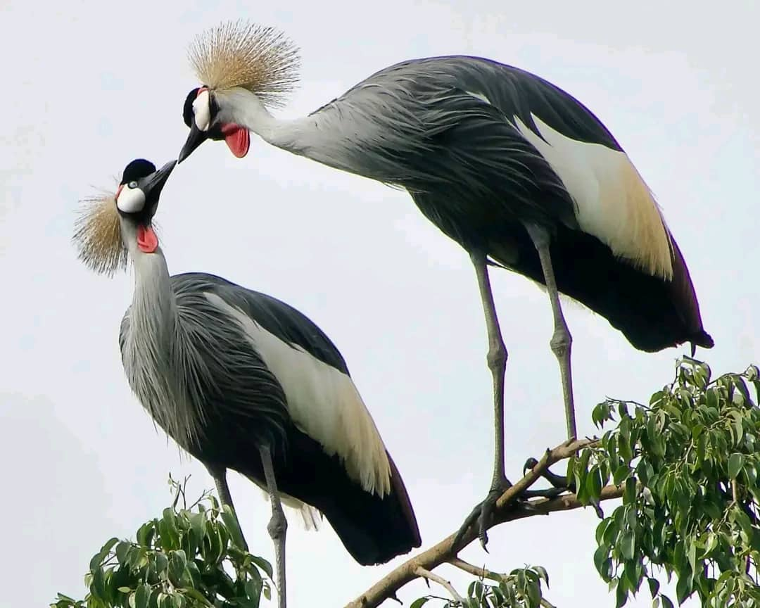

- Bicycle/ Amagare

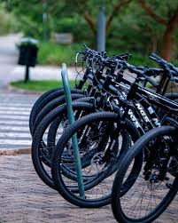

Nature in the City / Ibidukikije mu Mujyi
Discover nature, learn, and relax in a peaceful environment right here in the city.Turn your curiosity into a real experience and discover our hidden beauty.
Vumbura ibyiza by'ibidukikije, wige, kandi uruhukire ahantu hatuje mu mujyi hagati.Hindura amatsiko yawe ubumenyi bufatika uze wirebere ubwiza bwihishe muri iyi pariki.

Experience the Magic / Ibyo Wahigira n’Ibyo Wahabonera
- Explore Our Ecosystems: Learn about Rwanda's water bodies at our Learning Pond, representing Lake Kivu, Muhazi, Ihema, and Ruhondo.
  - Sura Urusobe rw'Ibinyabuzima: Ingera ubumenyi ku mazi y'u Rwanda basura Ikiyaga cy'Imyigishirize, kigaragaza Ikiyaga cya Kivu, Muhazi, Ihema, na Ruhondo
• Wildlife & Nature: See turtles and various birds in their natural wetland habitat.
- Ibinyabuzima: Reba utunyamaswa nka tureture n'inyoni zitandukanye mu Gishanga.
• Fun & Connection: Perfect for walking, cycling, or creating unforgettable moments as a couple

Imyidagaduro: Ni ahantu heza ho gutemberera n'amaguru, ku igare, cyangwa kuhagirira ibihe byiza n'uwo ukunda.
• Family Friendly: Dedicated children's playground and safe relaxation areas for everyone.

- Abakundana : Ni ahantu hatuje, heza, kandi hafite umutekano ku bakundana kuhagirira ibihe bitazibagirana.

Park Rules & Fees / Amategeko n’Ikiguzi
- Entry Fee : 2,000 RWF for Rwandans, designed to be affordable for everyone , 5,000Rfw for African citizen and 20,000 Rfw for international visitors
- Ikiguzi cyo kwinjira : Ni 2,000 RWF ku banyarwanda kugira ngo buri wese abashe kuhasura.
- Rules : No littering, no noise, no feeding animals, and do not collect wood.
- Amategeko : Kwirinda kujugunya imyanda nka plastic , gusakuza, kugaburira inyamaswa, cyangwa gusenya inkwi muri pariki.

Call to Action / Inama ku Basura
- Visit Today : Turn your curiosity into a real experience at Nyandungu Eco-Park.
- Sura Pariki : Hindura amatsiko yawe ibyishimo bifatika usura Nyandungu Eco-Park uyu munsi.

